# Apply filters to SQL queries

## Project description

In this lab activity, I will use the AND, OR, and NOT operators to create more complex filters for SQL queries.

## Retrieve after hours failed login attempts

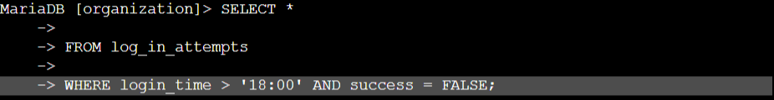

The > ‘18:00’ will show me logins after 6 pm. The AND success = FALSE; will show me the failed login attempts after my specified time.

## Retrieve login attempts on specific dates

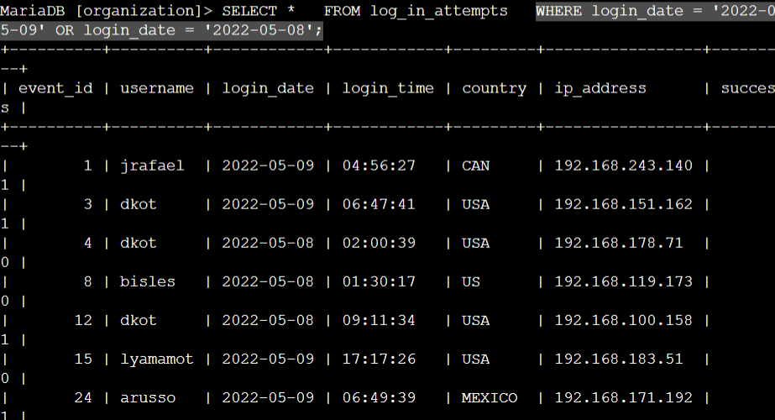

The OR condition allows me to search for multiple true conditions. In this instance, multiple specific dates.

## Retrieve login attempts outside of Mexico



In this filter I am retrieving data of login attempts outside of Mexico. Because it is a country with an abbreviation I am mindful to make use of the LIKE condition to retrieve data from sources named Mexico or MEX.

## Retrieve employees in Marketing

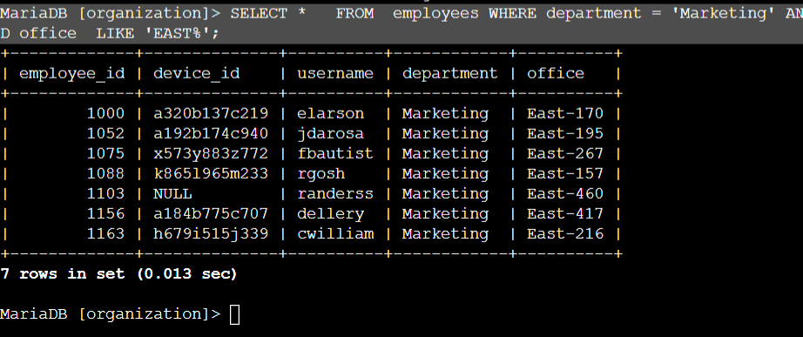

In this query I am retrieving employees in Marketing department in the “East” Office.

## Retrieve employees in Finance or Sales

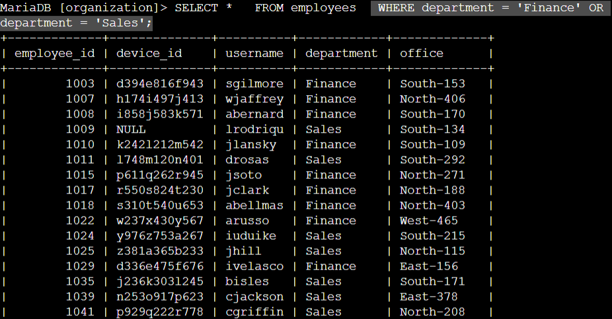

## Retrieve all employees not in IT

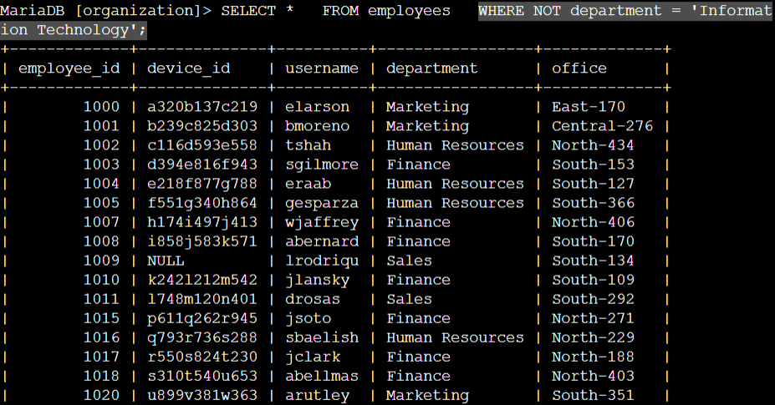

WHERE NOT

## Summary

The following lab demonstrates I can run SQL queries to retrieve information from a database and apply AND, OR, and NOT operators to filter SQL queries.